**Islamic Prints Frame Set of 3**

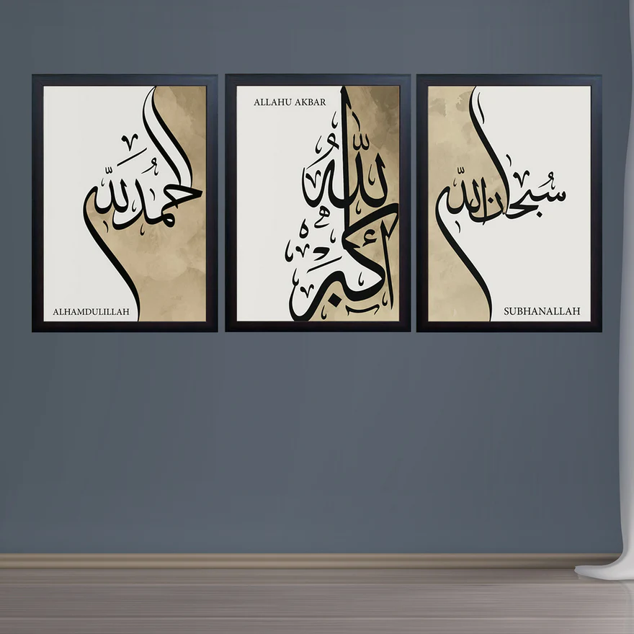An Islamic Prints Frame Set of 3 is a beautiful and meaningful collection of artworks that reflects the rich cultural and spiritual heritage of Islamic art. Typically featuring intricate geometric patterns, calligraphy from the Quran, or depictions of significant Islamic landmarks, these prints are often framed in elegant designs that complement a variety of interior styles. Whether displayed together as a set or spread across different rooms, they add a sense of tranquillity, faith, and cultural depth to your home or office. The frames are usually crafted from wood, metal, or other high-quality materials, making them a durable and visually stunning addition to any space. Ideal for living rooms, entryways, or prayer rooms, an Islamic Prints Frame Set of 3 brings both beauty and spirituality to your décor.